First make sure that you have the proper Android studio version installed (0.4.6)

You could download this version from

<http://tools.android.com/download/studio/canary/0-4-6>

In order to import the project form bit bucket you do have to install mercurial, go to this website and download " [TortoiseHg with Windows Explorer "shell" integration](http://tortoisehg.bitbucket.org/download/index.html)"

<http://mercurial.selenic.com/wiki/Download>

After that, bitbucket needs to know that your computer is an authorized computer to push and pull changes from the repository, to do that you have to make a key and add it to your bitbucket account.

First, go to this website and install [puttygen.exe](http://the.earth.li/~sgtatham/putty/latest/x86/puttygen.exe) and [pageant.exe](http://the.earth.li/~sgtatham/putty/latest/x86/pageant.exe)

<http://www.mono-project.com/Putty_and_TortoiseSVN>

After you download them, launch puttygen.exe and this will come out

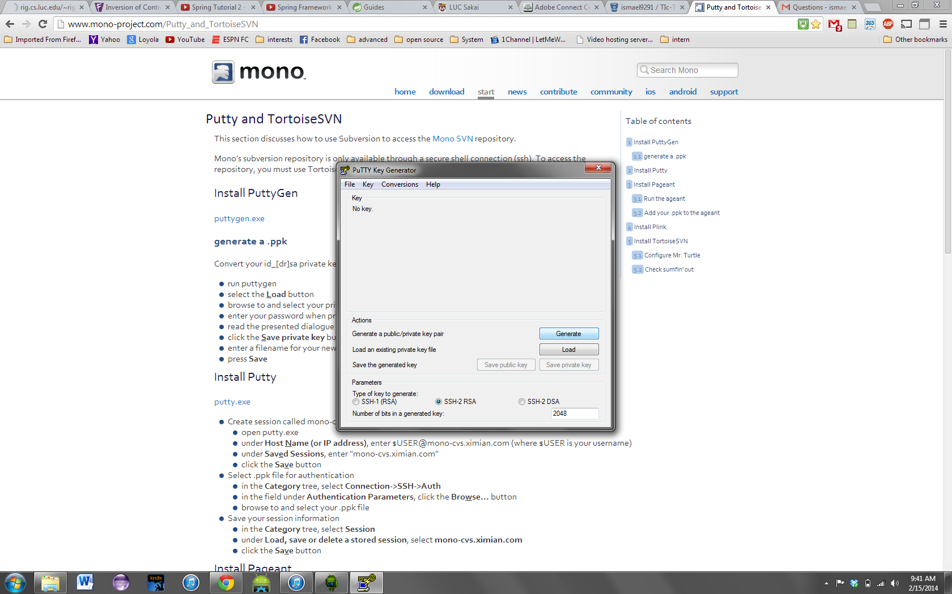

Hit generate and you will have to move the mouse around the blank space of the box, you cant see my pointer but just move randomly in that box and you will see that the bar is filling up as you do it more and more

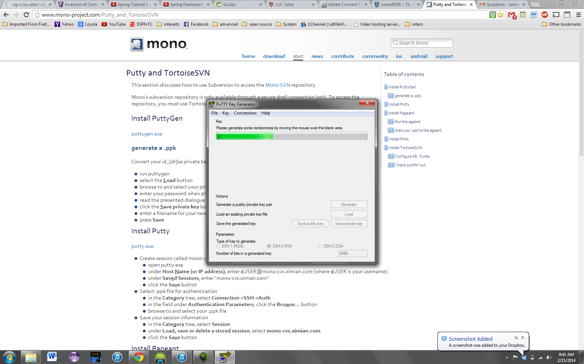

After it finishes this window will come up and you have to put in your own password for the key

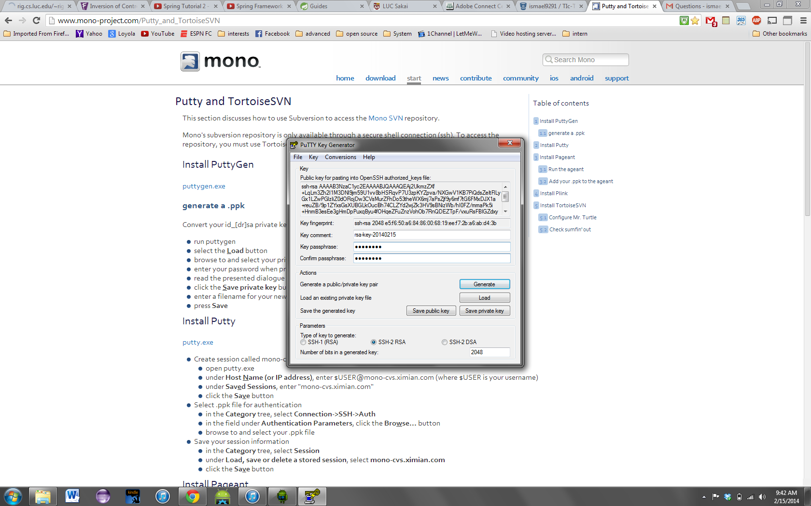

Next, before you save the private key somewhere in your computer, copy and paste the context of the key, look bellow so you could see exactly what I an referring to.



next, go to bitbucket, go to manage account

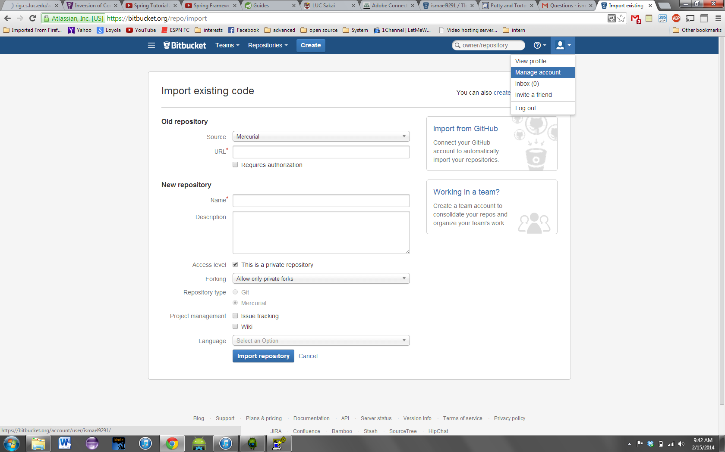

Then ssh key

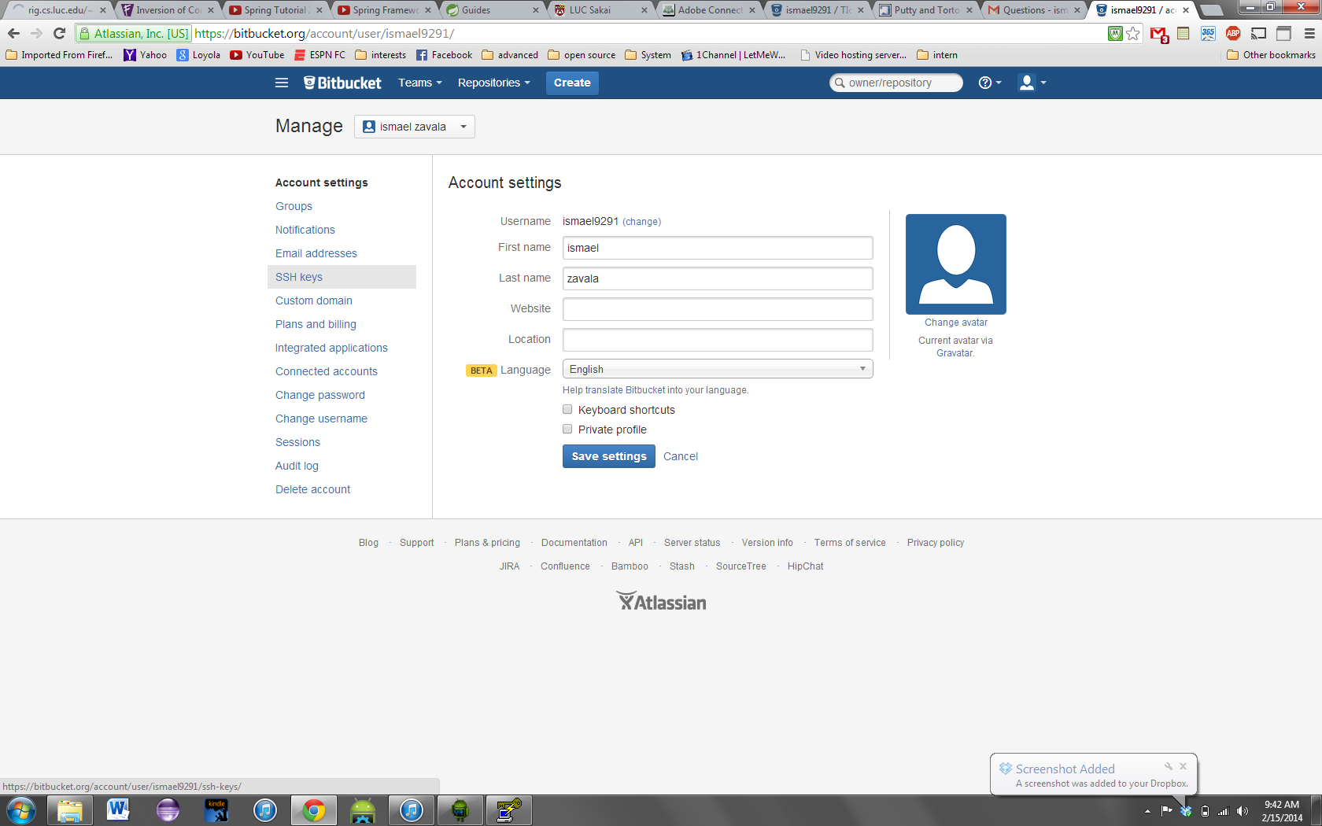

then add key

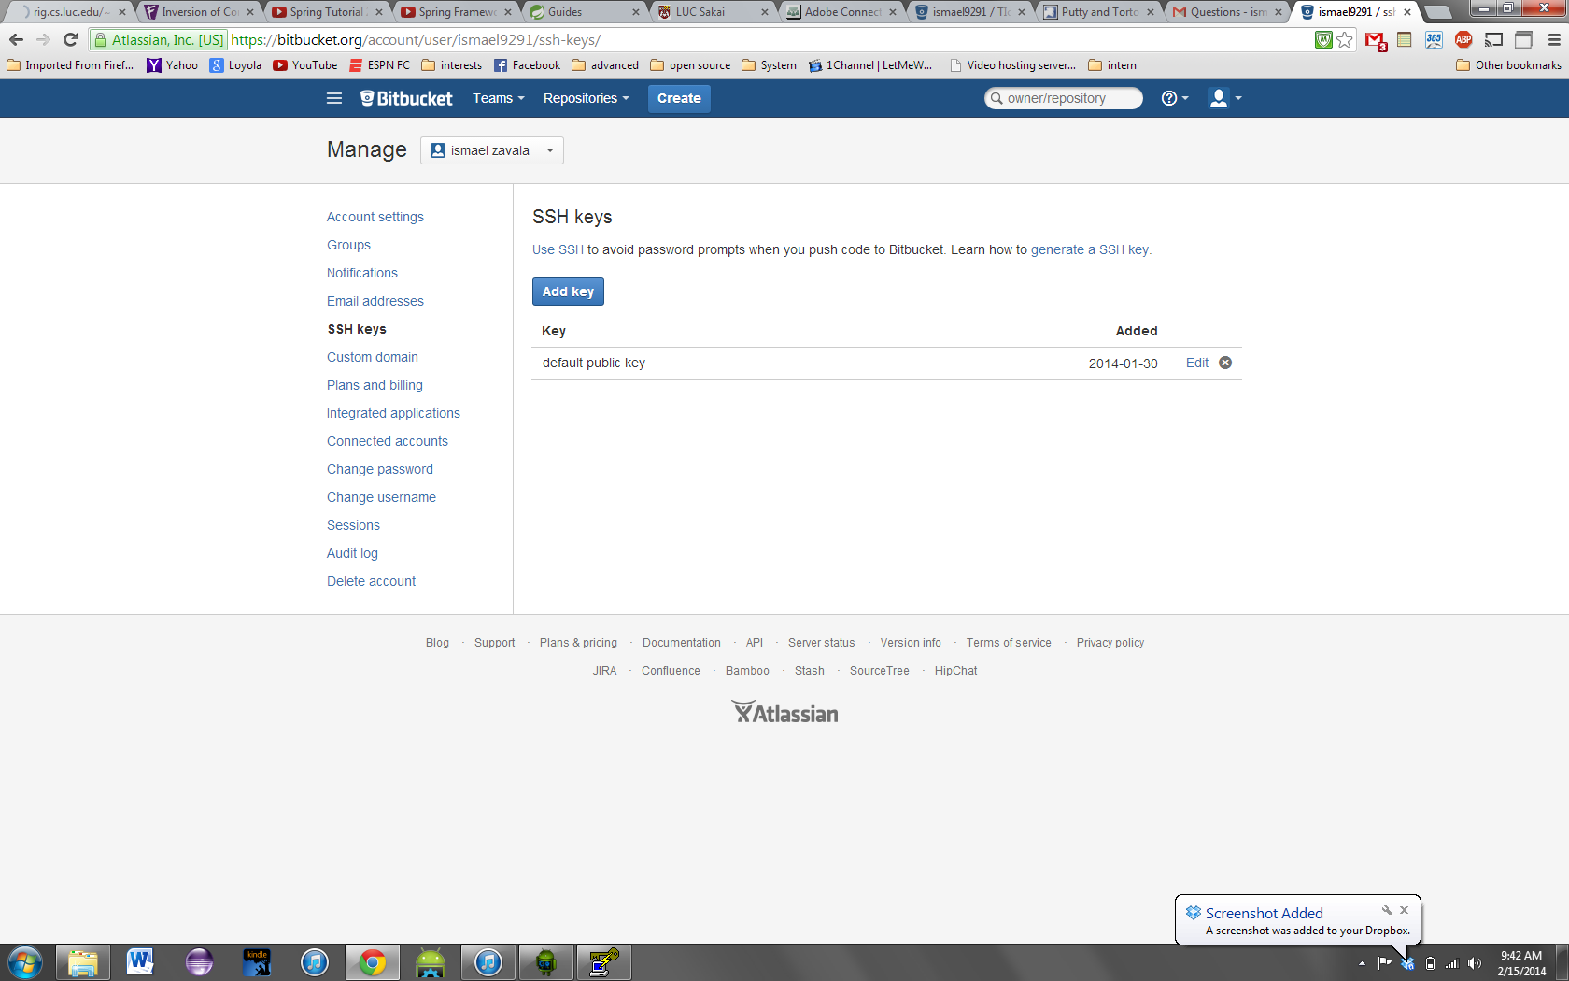

then bellow, paste what you copied earlier into the key section

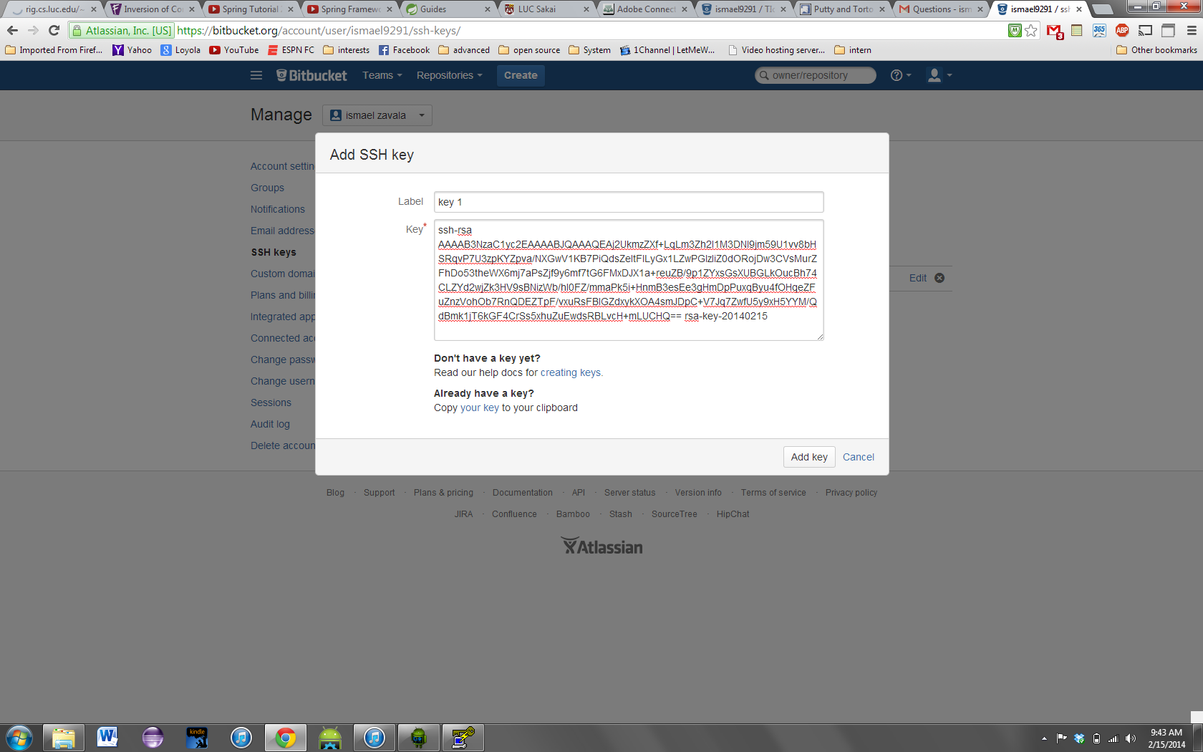

Then press add key, then you have to save the key that you generated back to the putty.gen, save it as both a private and public key, because i forgot which one really matters, so to make sure just save as both formats,

After you saved it in a place you remembered, you could open pageant, the other program you downloaded, and press add key

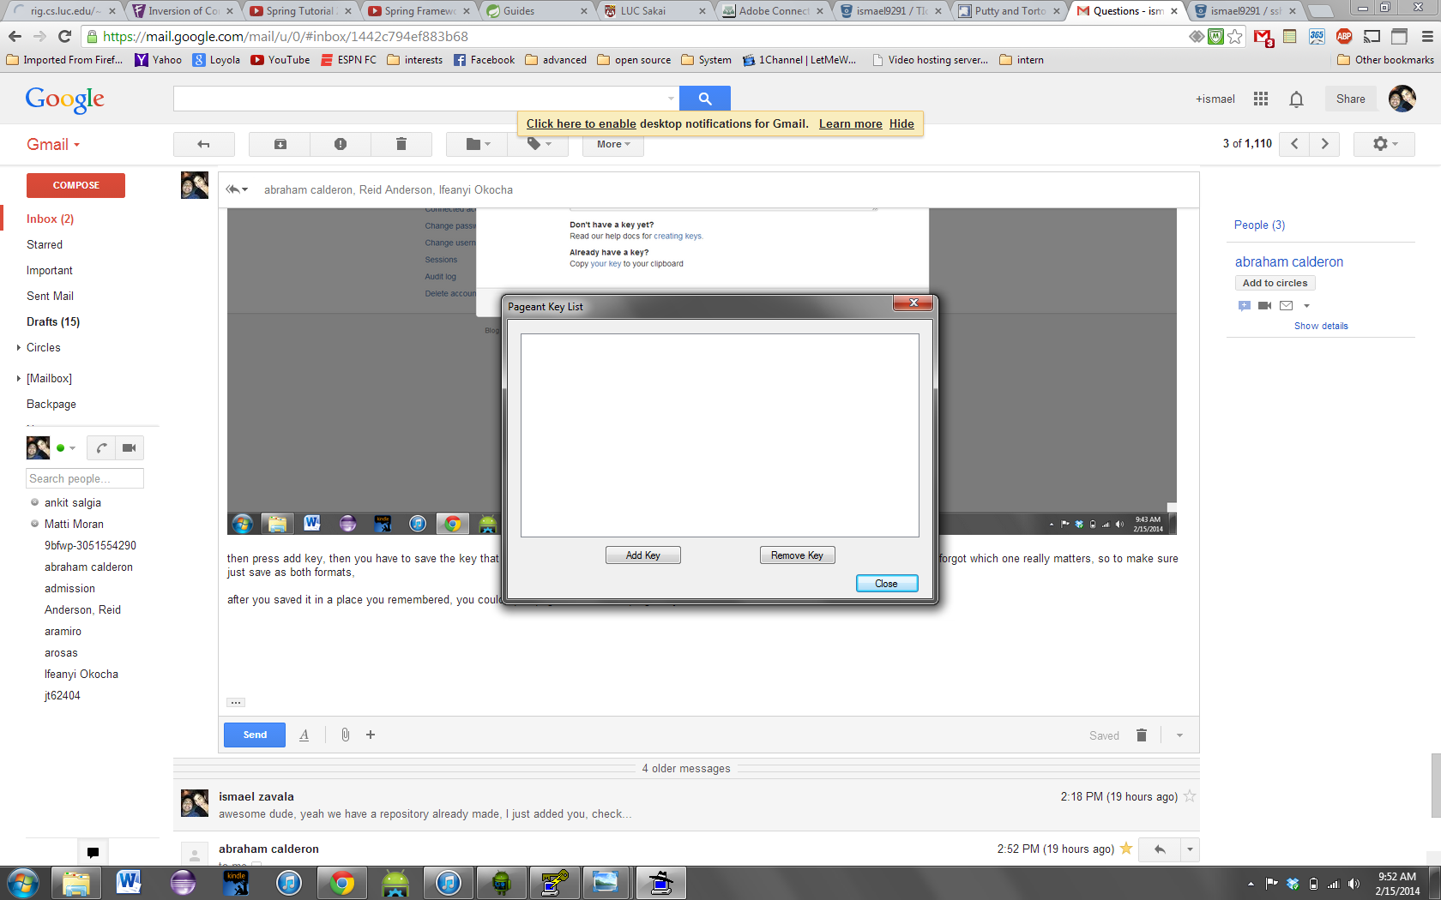

Look for the keys you generated and add them

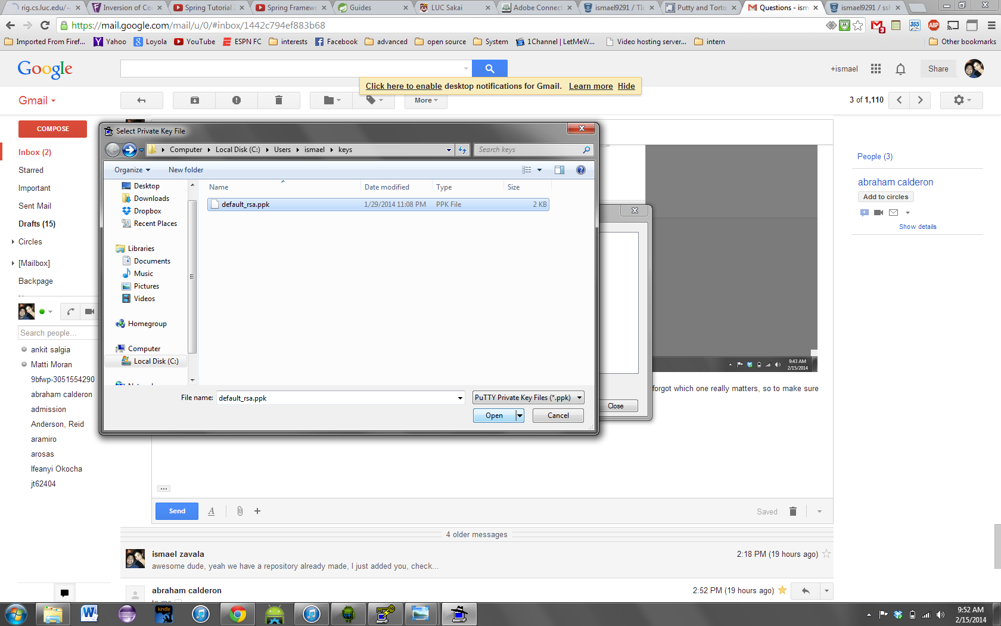

It will then ask for the password you entered earlier when you saved the key, enter it and it will be added to pageant

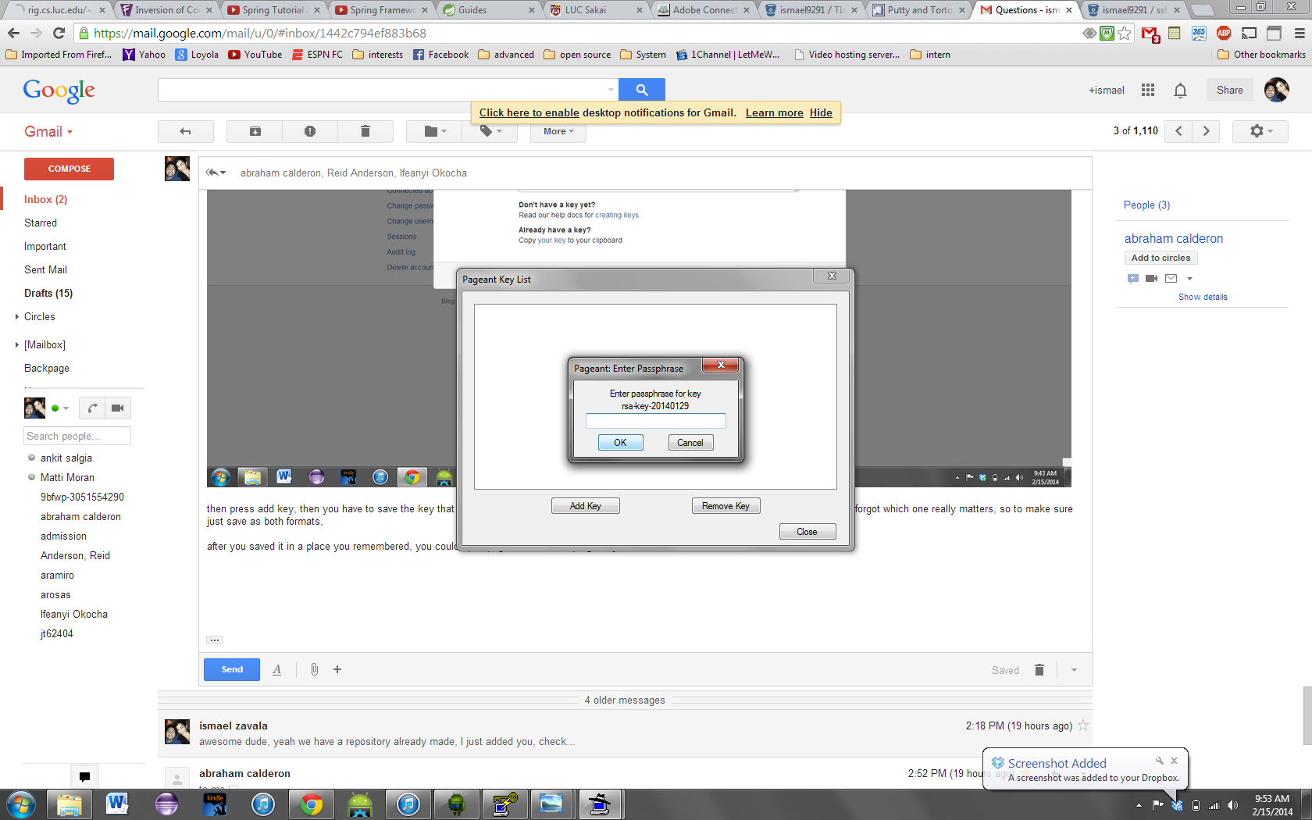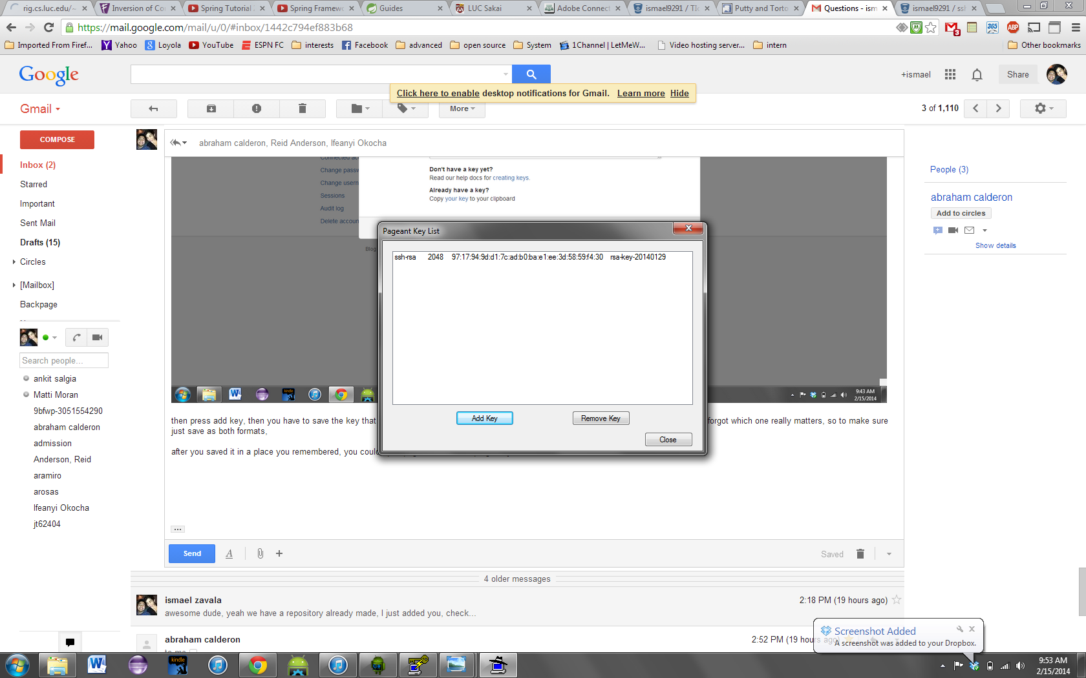

Now that you added the key to pageant, you are able to import the repository and make pushes and pulls of the repository.

After you have pulled the project into android studio, There are different options to run the application. The easiest is running it through an emulator created within Android studio.

The following, are instructions on how to create the emulator to run within your computer

Open android studio and click on the AVD manager, as seen below.

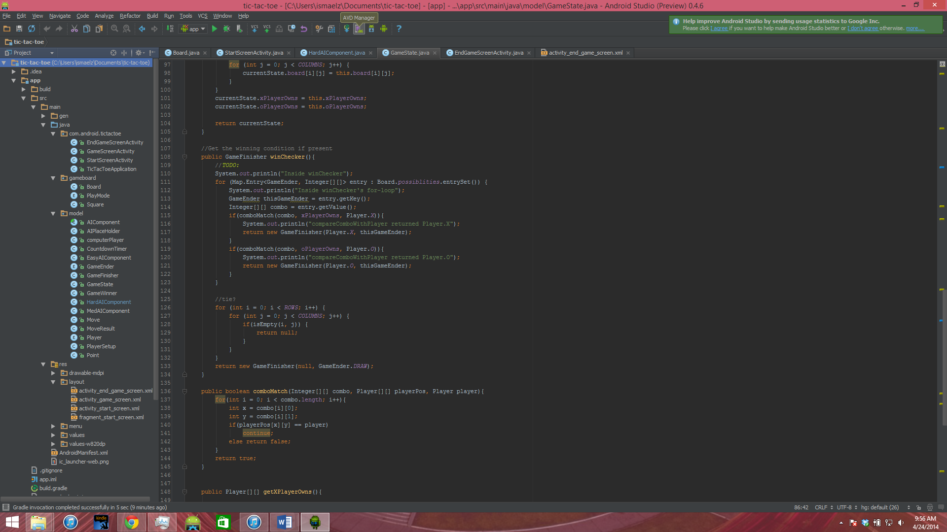

A window should open, and click on new

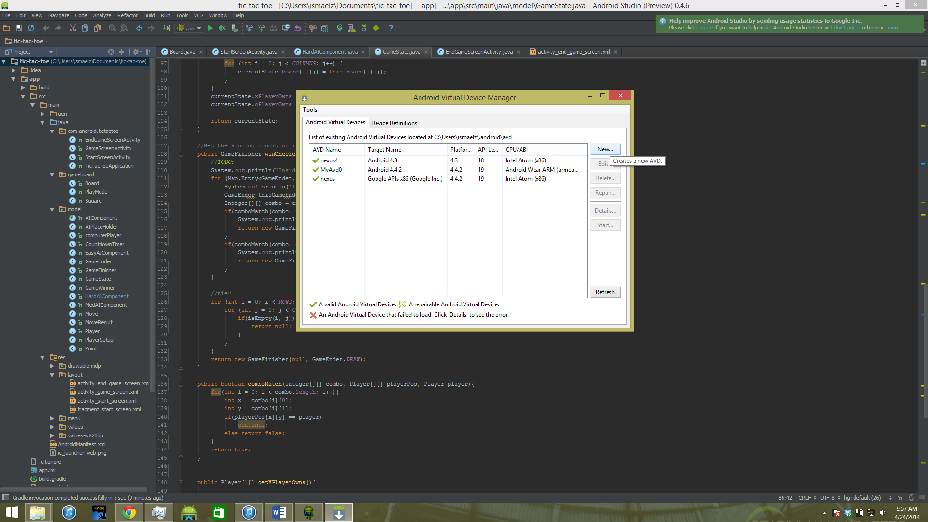

The following window should open

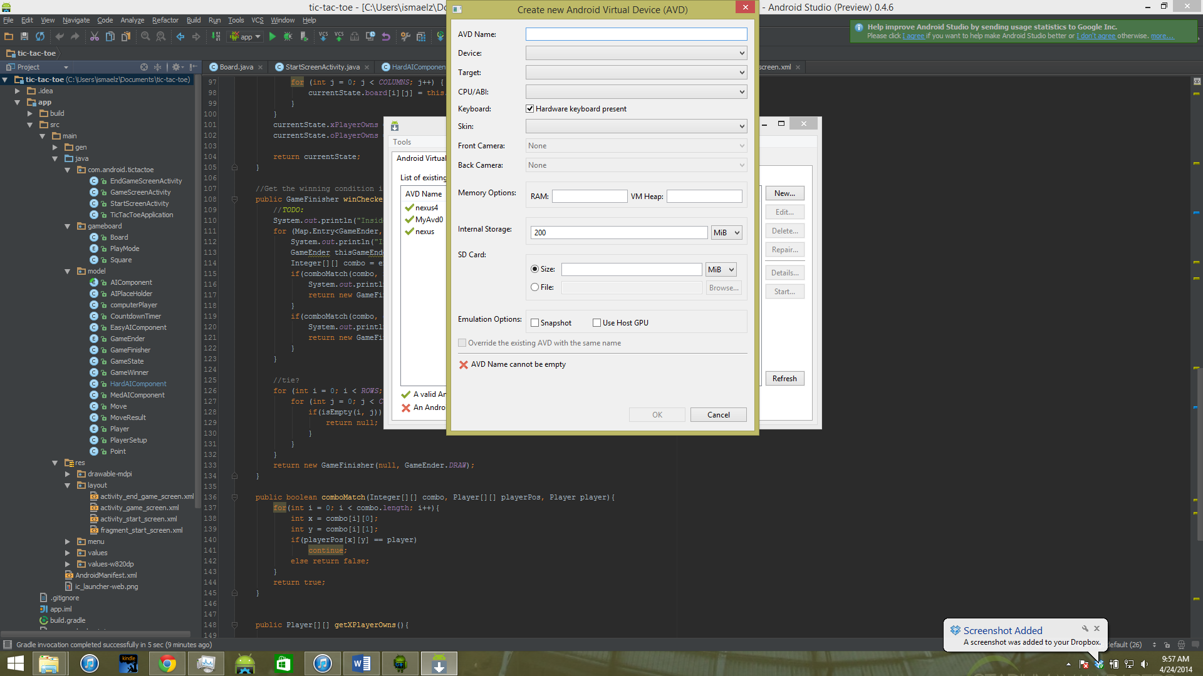

Fill it out with the following configurations

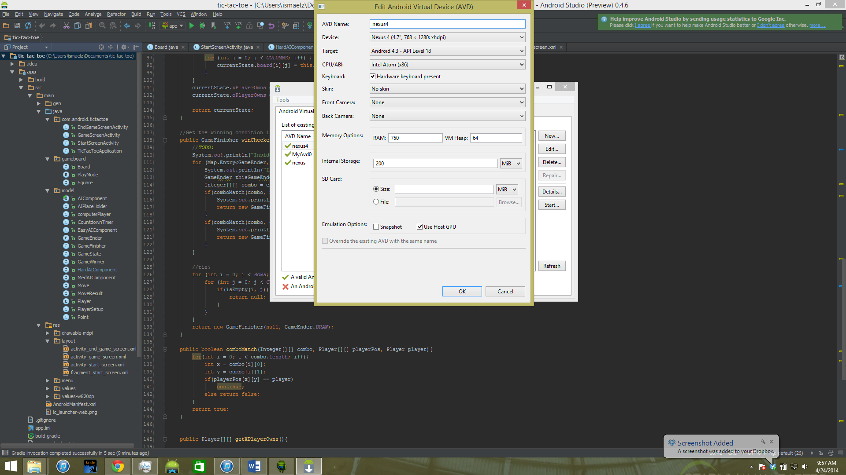

Press OK, and the following confirmation window should come up

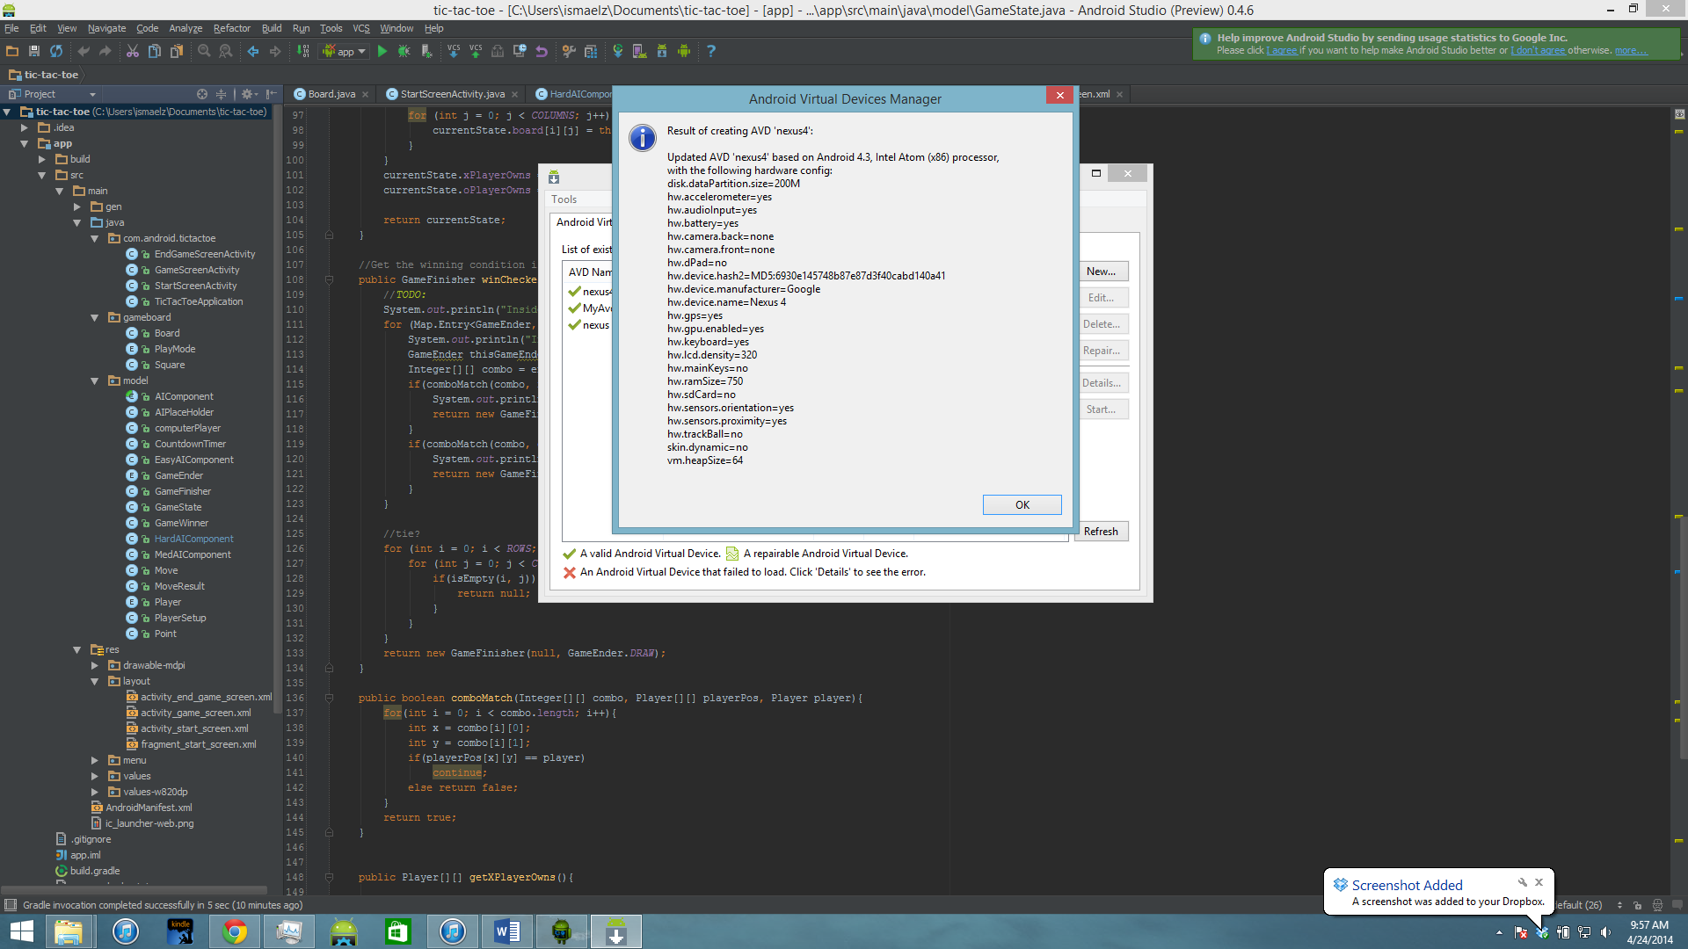

The emulator is now set!

The following instructions is to run the applications using the emulator. Open the AVD manager, select the emulator you created, and press start

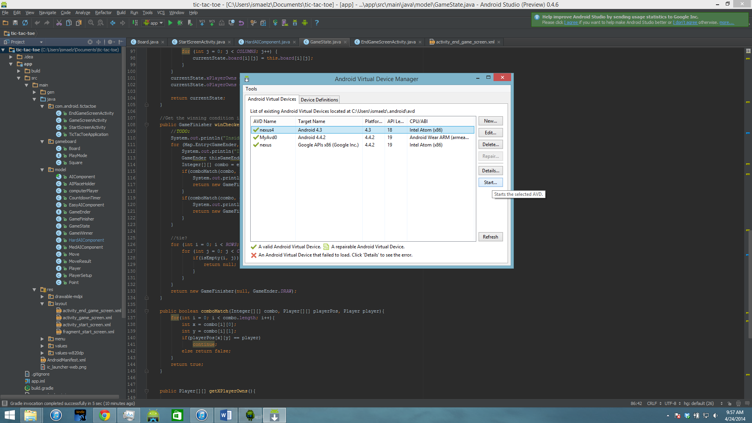

This window should come up, and select Launch.

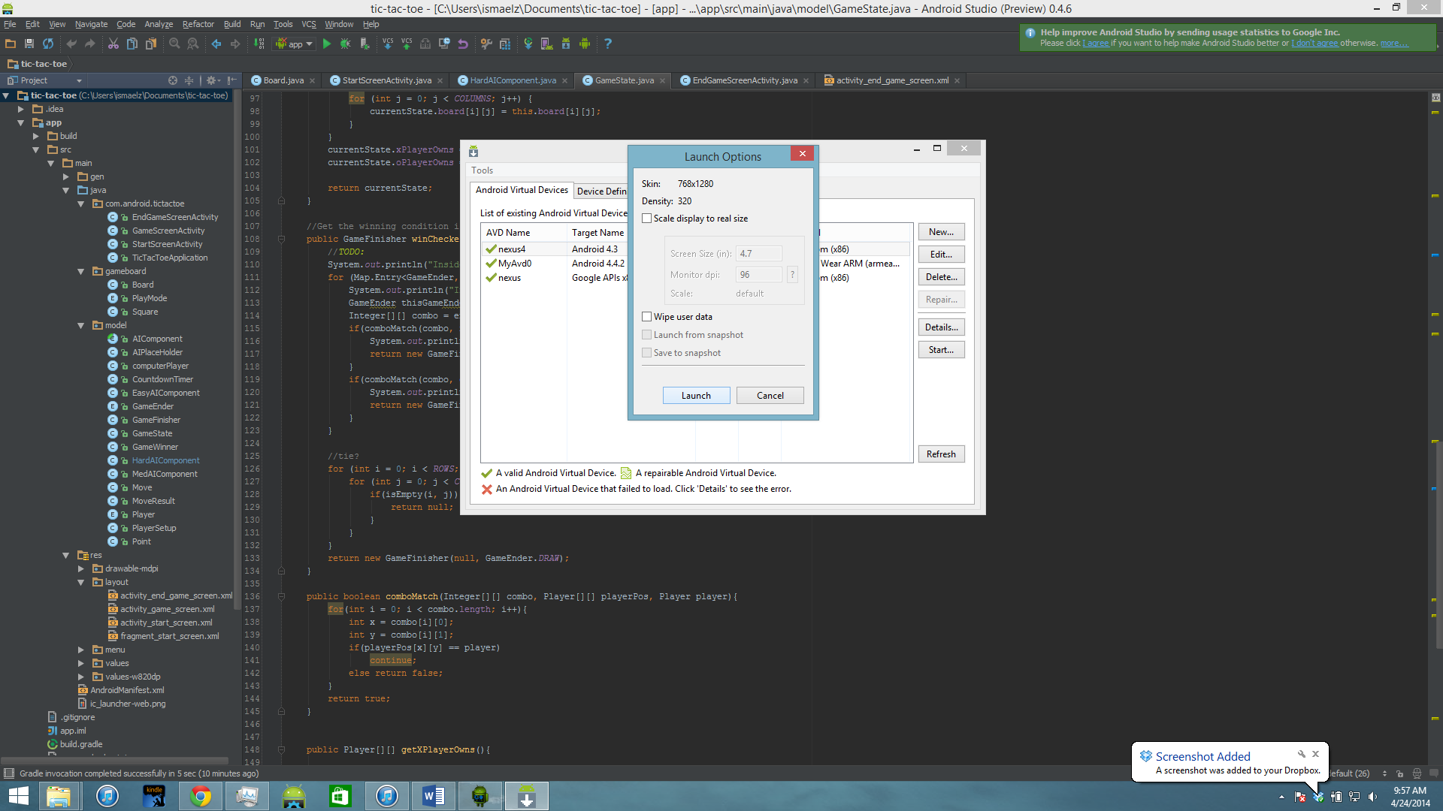

The emulator then will begin its launch,

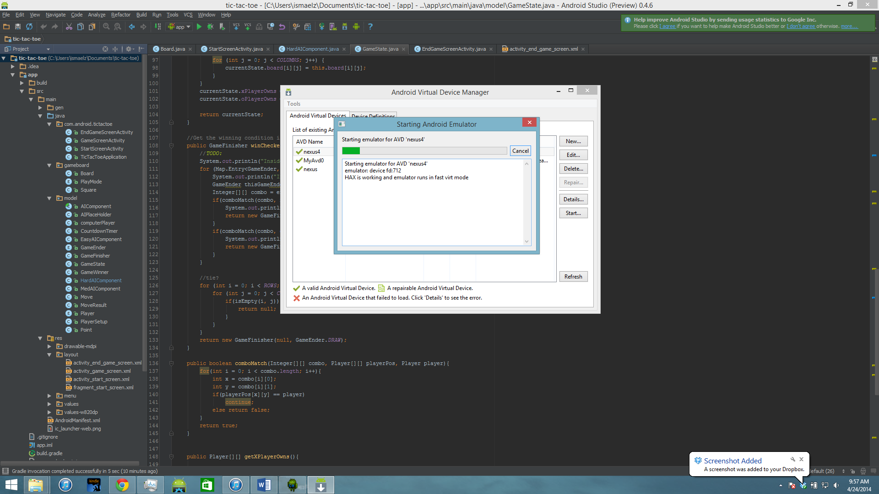

When this window finishes, a black screen should pop up, this is the emulator, it will most likely take a while for the emulator to finally be loaded. Depending on your machine, it will take a few minutes. The following picture is how the window should look once it is loaded.

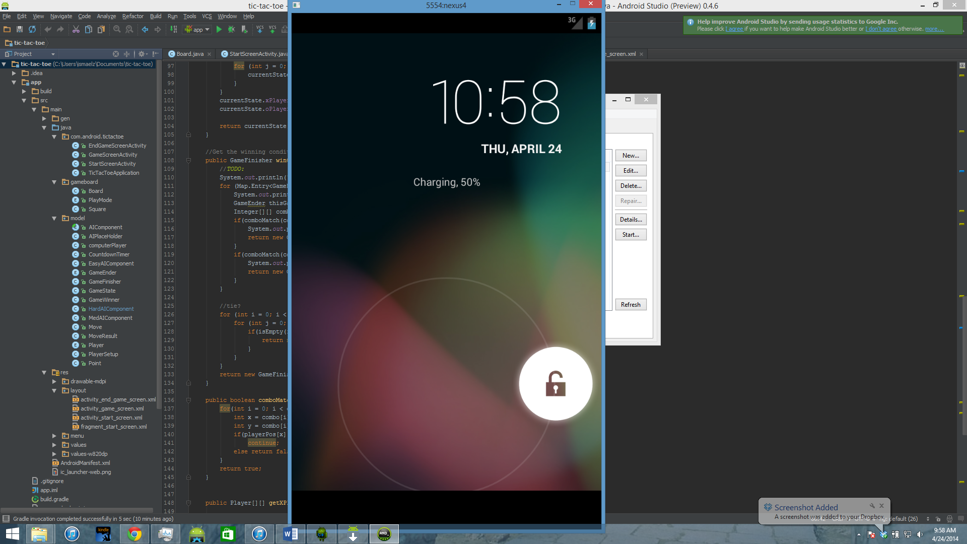

Unlock your emulator and the emulator is ready to run

Press the run button from android studio, the top green button as shown bellow

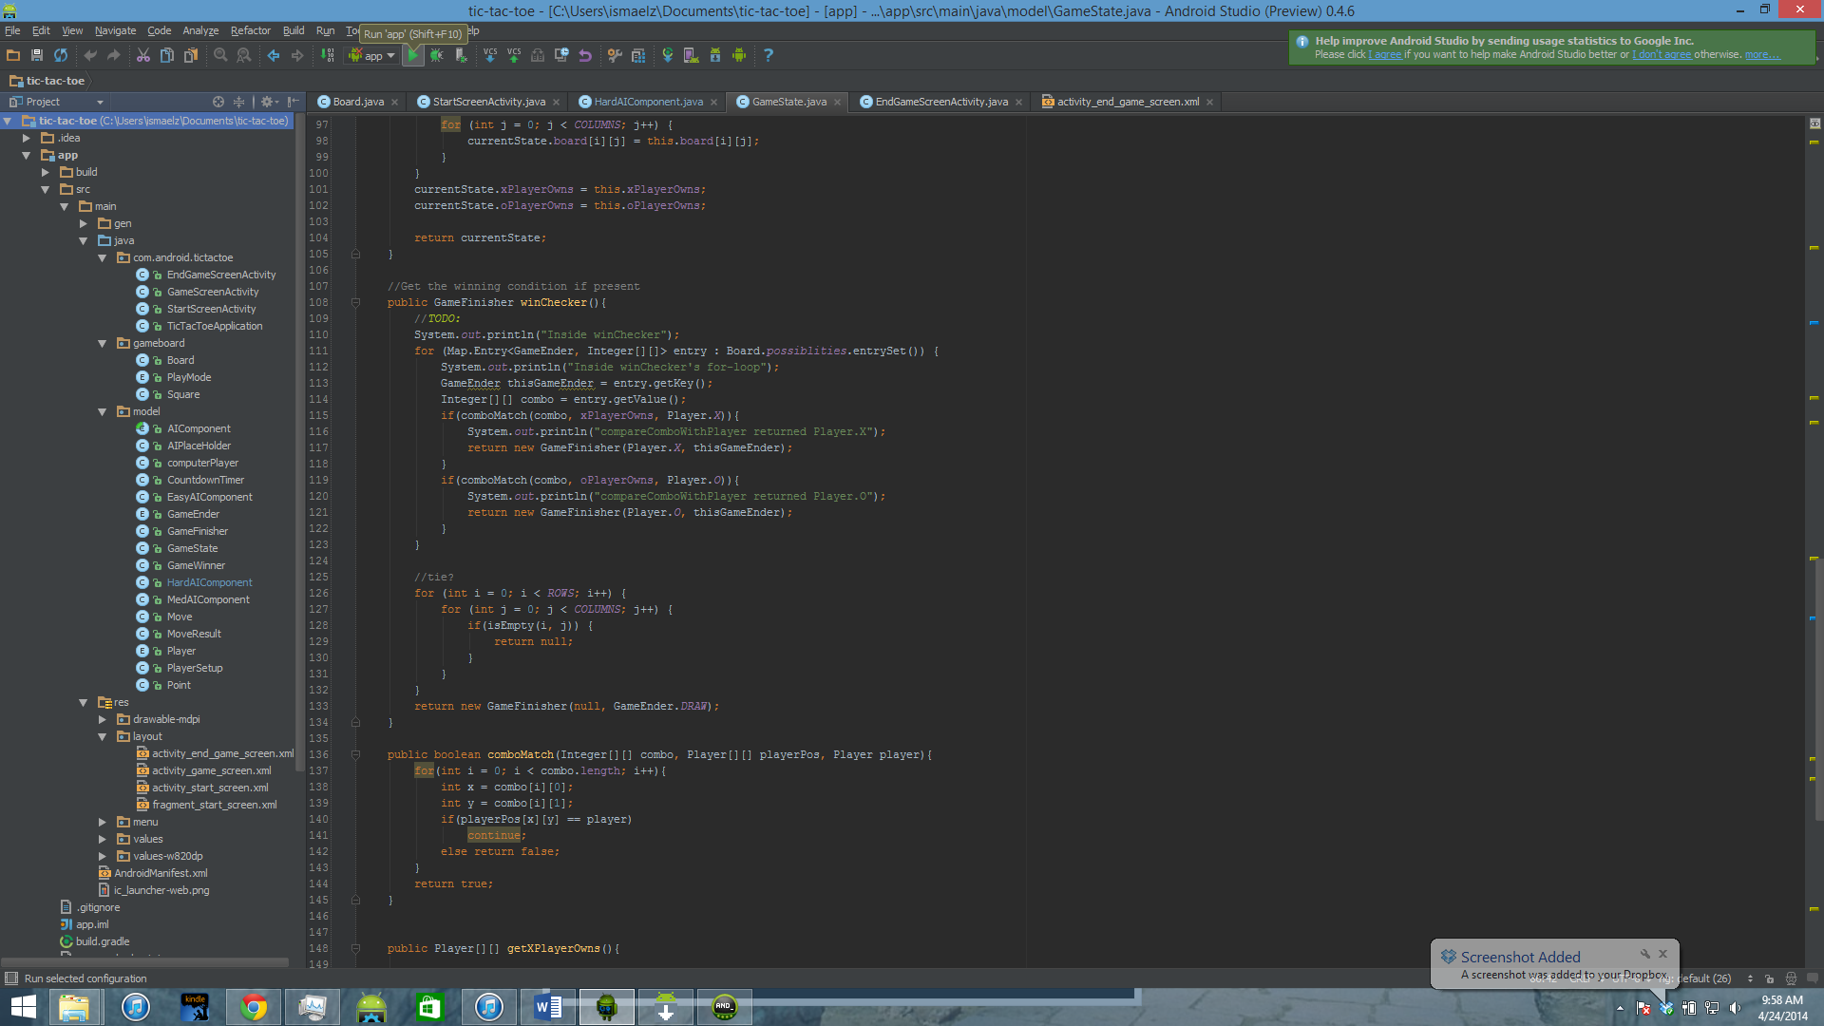

It may ask you which emulator to run, just select the emulator you created, The following pictures is what you should see as it runs.

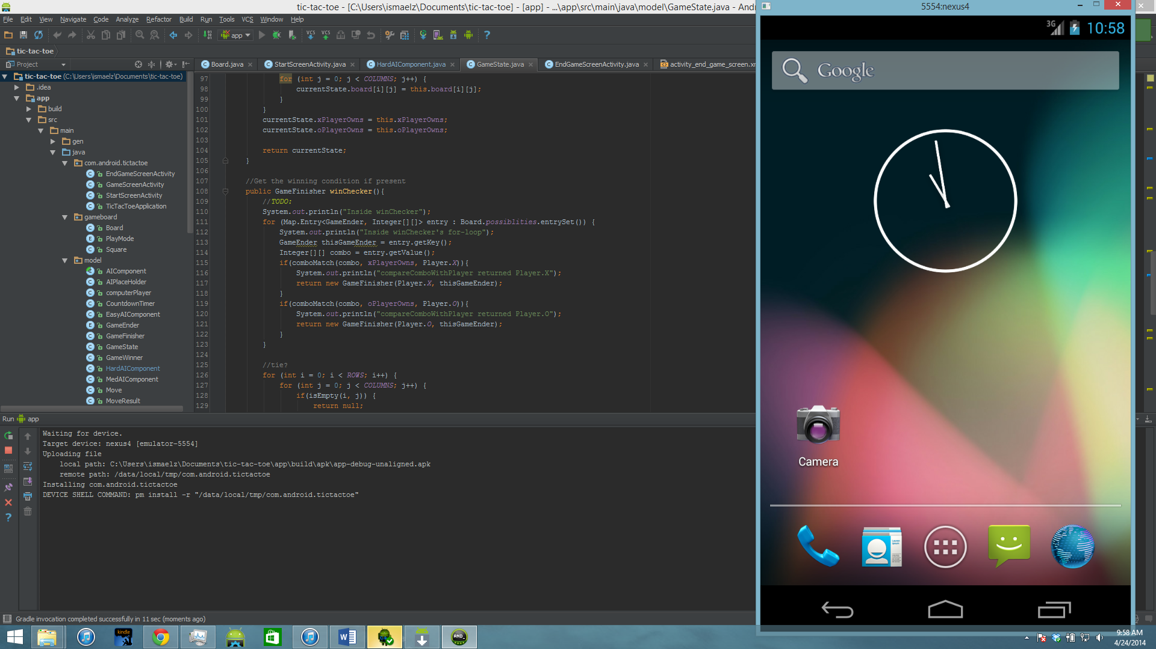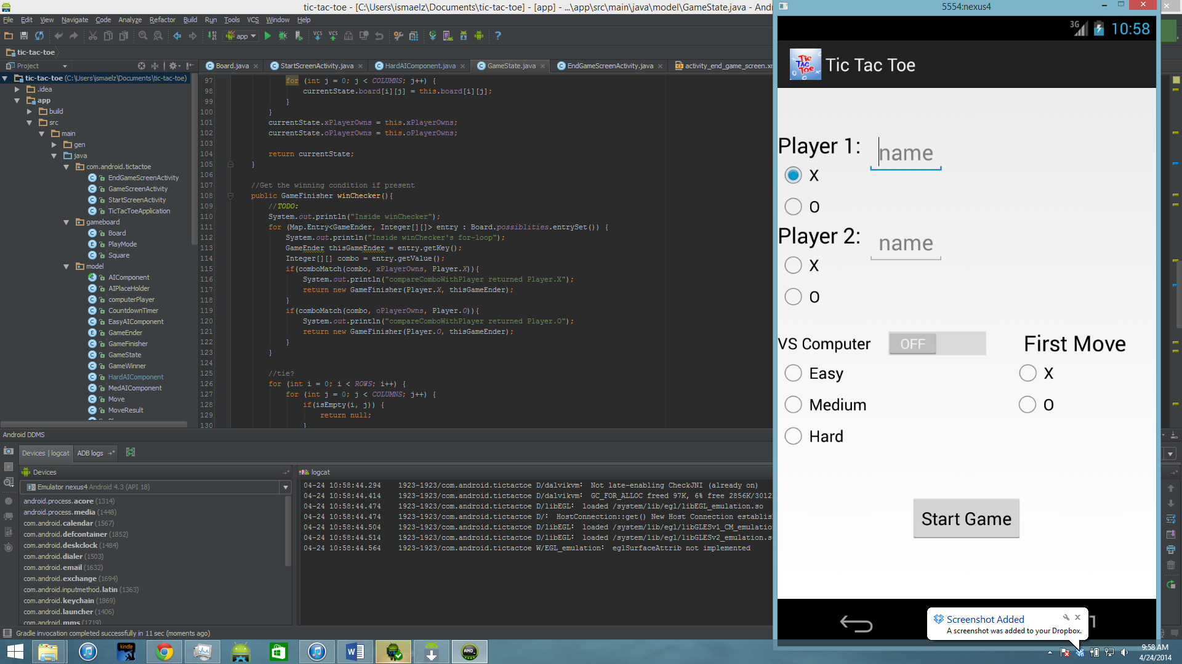

The application should launch straight to the emulator

Bellow are some recommendations to do, if your app fails to run

You must download all of the updates and build tools for android studio

Click on the SDK manager button, it is the button that is right next to the button you pressed to create the emulator

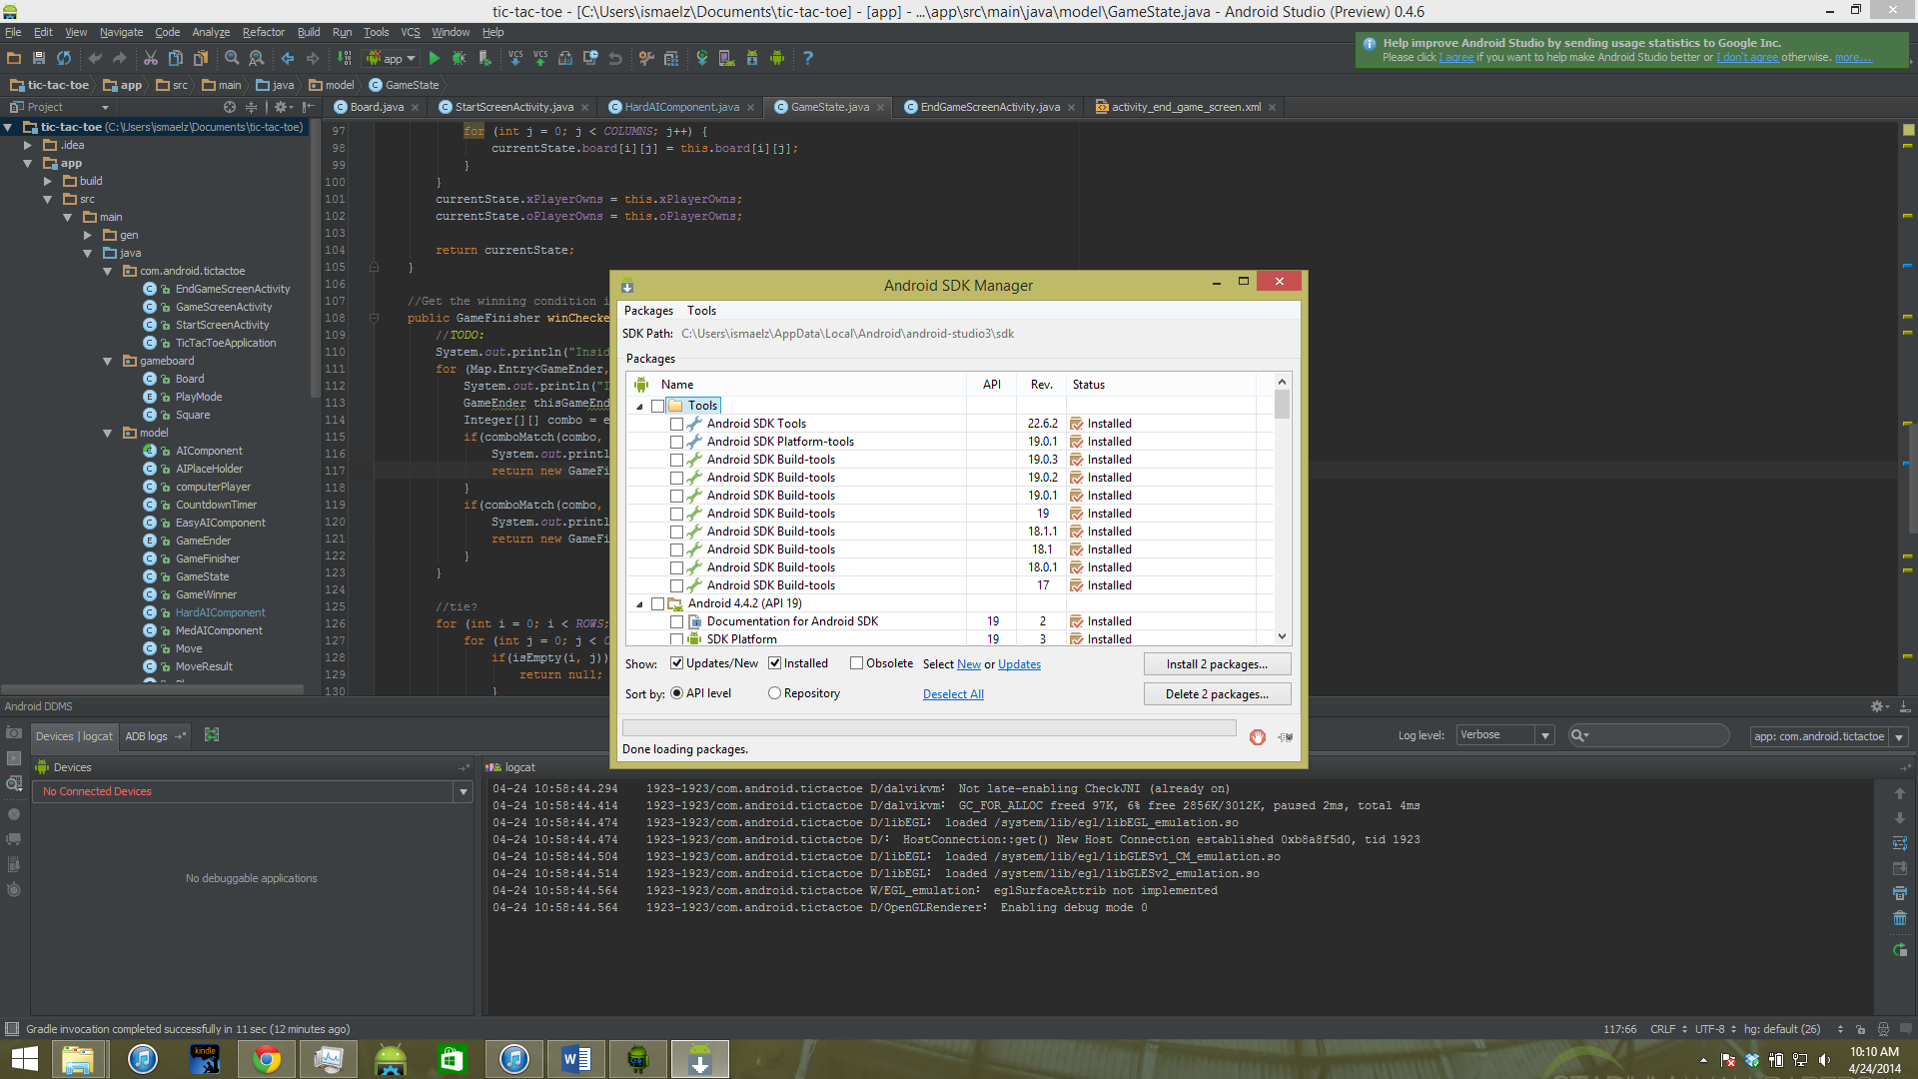

In the window that comes up, there should be all the updates possible for android studio, to see which are not installed in your system, just un check the installed box

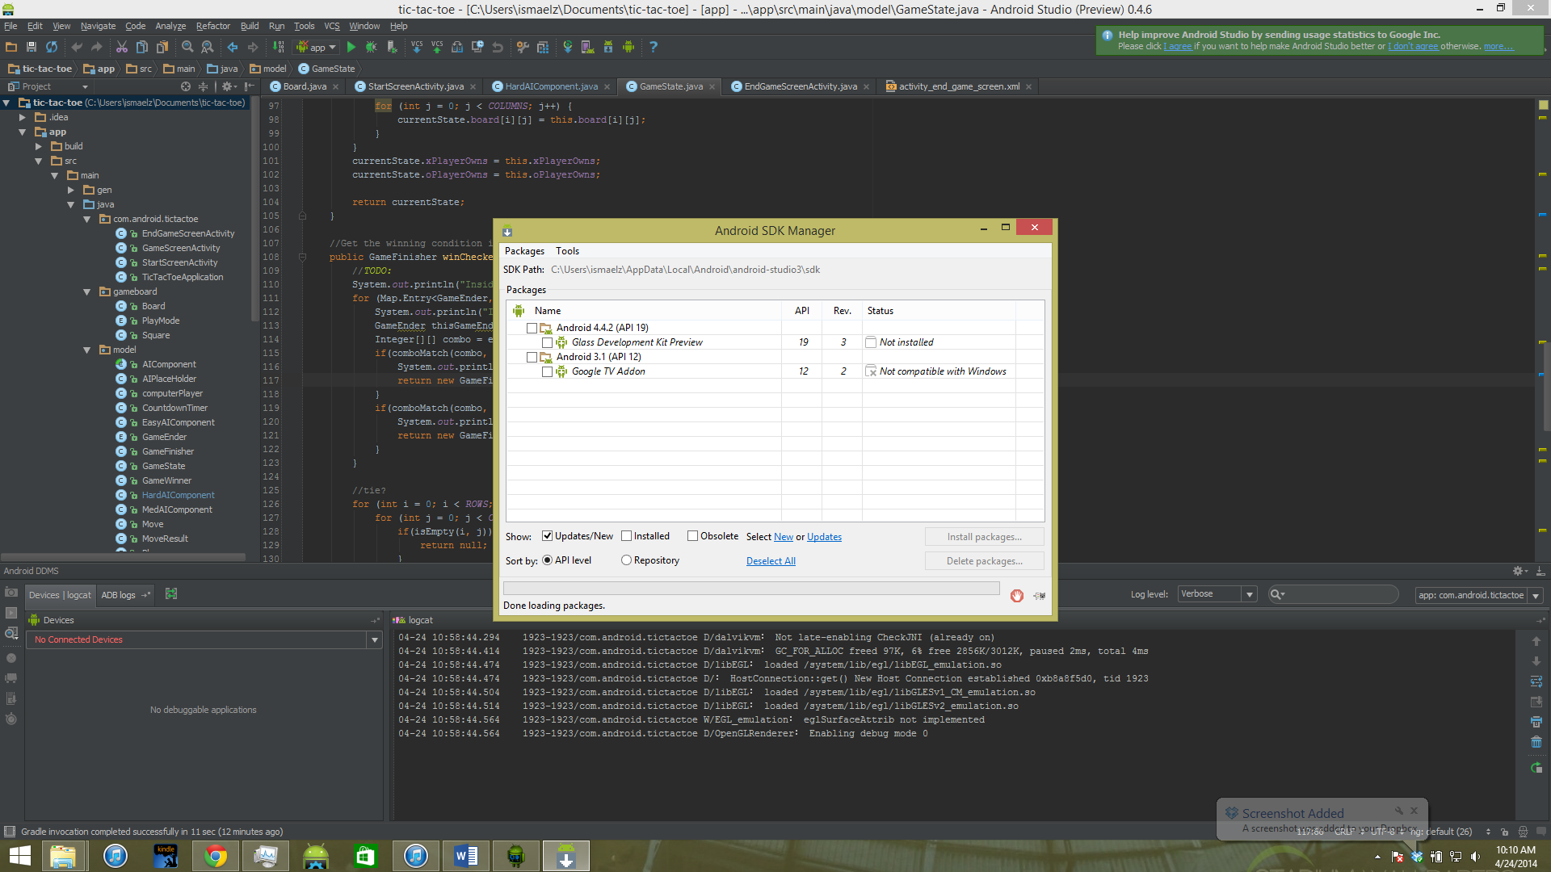

Make sure you install all of the updates you have left to install.